SAMBO
Sport Entry Manual

March 2019

Contents
1. Introduction

2. Sport Entry
2.1. Sport Entry Timeline
2.2. Sport Entry Process
2.3. Submission of Entry by Sport
2.4. Submission of Entry by Number
2.5. Submission of Entry by Name
2.6. 2nd TD Meeting and Confirmation of Final Entry
2.7. Arrival/Departure and VISA
3. Required Data Field
3.1. Entry by Sport
3.2. Entry by Number
3.3. Entry by Name
4. Sport Entry Policy
4.1. Eligibility
4.2. Events
4.3. Entry Policy
4.4. Accommodation Fee
4.5. Cancellation of Event
5. Contact Information
6. Sport Entry Form
6.1. Entry Form by Sport
6.2. Entry Form by Number
6.3. Entry Form by Name

1. Introduction
2019 Chungju World Martial Arts Masterships Organizing Committee (2019 Chungju WMOC) and FIAS (International SAMBO Federation) are responsible for managing effectively and accurately the qualifications and entries of athletes for the SAMBO competition in 2019 Chungju World Martial Arts Masterships. The sport entry process provides for the official entry of eligible and qualified athletes and teams into the 2019 Chungju World Martial Arts Masterships. FIAS has the authority to collect and approve the numbers and final lists of qualified athletes and team officials, and need to submit the sport entry to the 2019 Chungju WMOC.

2. Sport Entry
2.1. Sport Entry Timeline
March May June July
2019 2019 2019 2019
Entry by Sport

Deadline
March 31, 2019
Entry by Number

Deadline
May 15, 2019
Entry by Name

Deadline
June 30, 2019
2nd TD Meeting

July 15, 2019

2.2. Sport Entry Process
2019 Chungju WMOC will distribute the FIAS approved sport entry manual and form to FIAS on March 2019. FIAS will distribute sport entry manual and form to member National Federations of FIAS. The National Federation must submit the sport entry to FIAS no later than 10 days before the each deadline, referring to the schedule and contents in the table below. FIAS needs to submit the sport entries of National Federation to 2019 Chungju WMOC by the relevant deadline.
Entry | Content | Deadline
Entry by Sport | Number of Athletes and Team Officials by Country | 24:00 March 31, 2019  (Korean Standard Time, GMT +9)
Entry by Number | Number of Athletes and Team Officials by Country and Event | 24:00 May 15, 2019  (Korean Standard Time, GMT +9)
Entry by Name | Name of Athletes and Team Officials by Country and Event (Final Entry) | 24:00 June 30, 2019  (Korean Standard Time, GMT +9)
2nd TD Meeting | Review and Confirmation of Final Entry | July 15, 2019  (TBD)

2.3. Submission of Entry by Sport
Each National Federation participating in the SAMBO competition of 2019 Chungju World Martial Arts Masterships must fill out the ‘Entry by Sport form(number of athletes and team officials by country)’ and submit it to FIAS e-mail(info@sambo-fias.com) by March 21, 2019, 10 days before the deadline, and FIAS need to submit the ‘Entry by Sport’ of each National Federation to 2019 Chungju WMOC email(entry.chungju2019@gmail.com) by March 31, 2019.

2.4. Submission of Entry by Number
Each National Federation participating in the SAMBO competition of 2019 Chungju World Martial Arts Masterships must fill out the 'Entry by Number form(number of athletes and team officials by country and event)' and submit it to FIAS e-mail(info@sambo-fias.com) by May 5, 2019, 10 days before the deadline, and FIAS need to submit the 'Entry by Number' of each National Federation to 2019 Chungju WMOC email(entry.chungju2019@gmail.com) by May 15, 2019.
2.5. Submission of Entry by Name
Each National Federation participating in the SAMBO competition of 2019 Chungju World Martial Arts Masterships must fill out the 'Entry by Name form(name of athletes and team officials by country and event)' and submit it to FIAS e-mail(info@sambo-fias.com) by June 20, 2019, 10 days before the deadline, and FIAS need to submit the 'Entry by Name' of each National Federation to 2019 Chungju WMOC email(entry.chungju2019@gmail.com) by June 30, 2019.

2.6. 2nd TD Meeting and Confirmation of Final Entry
2019 Chungju WMOC will hold a 2nd TD Meeting on July 15, 2019. During the 2nd TD meeting, the final sport entry for athletes and team officials of all sports will be confirmed. After the confirmation of sport entry on July 15, 2019, it cannot be changed. National Federation that withdraws their athletes or team officials after the final submission of the final entry by name will be subject to disciplinary action by FIAS.
Once the details of the 2nd TD meeting are confirmed, it will be notified to each IF.

2.7. Arrival/Departure and VISA
Participants including athletes and team officials must apply for a visa to the Korean embassy or consulate in their native country unless they can enter the Republic of Korea without a visa. If a participant requires a visa to enter the Republic of Korea, and needs an official invitation for the Masterships, an Invitation Application Form along with a copy of passport should be submitted to the 2019 Chungju WMOC at visa.chungju2019@gmail.com by June 30, 2019. Each National Federation is strongly recommended to gather all applications and copies of passport of its participants and submit them all at once. Please refer to the Accreditation Guide to be sent in April 2019 when filling out the application form. A letter of invitation will be sent to each National Federation after the application forms are submitted and verified. Please note that it is the responsibility of each individual to obtain the entry visa and that 2019 Chungju WMOC’s invitation letter is not a guarantee for the visa to be granted. All delegates traveling to Korea must have a passport that is valid for at least six months after the intended date of entry into Korea for the Masterships.
Visa application procedure and requirements for all travelers to Korea can be found at https://www.visa.go.kr/openPage.do?MENU_ID=10105
3. Required Data Field
3.1. Entry by Sport (by March 31, 2019)
Information of Athlete & Team Official | VERIFICATION & CONFIRMATION
• Nationality (Country and Code)  • Number of Athlete by Country  • Number of Team Officials by Country | • Name of IF(International Federation)  • Name of IF President  • Signature of IF President  • Official Seal of IF
※ The number of team officials per each National Federation must not exceed 50% of their total number of participating athletes.

3.2. Entry by Number (by May 15, 2019)
Information of Athlete & Team Official | VERIFICATION & CONFIRMATION
• Nationality (Country and Code)  • Number of Athlete by Country and Event  • Number of Team Officials by Country | • Name of NF(National Federation)  • Name of NF President  • Signature of NF President  • Official Seal of NF

3.3. Entry by Name (by June 30, 2019)
Information of Athlete & Team Official | VERIFICATION & CONFIRMATION
• Nationality (Country and Code)  • Gender  • Family Name (same on the passport)  • Given Name (same on the passport)  • Date of Birth (dd-mm-yyyy)  • Height (cm)  • Weight (kg)  • Blood Type  • Best Record (Previous Games)  • Athlete's Registration Number (Issued by IF) | • Name of NF(National Federation)  • Name of President of NF  • Signature of President of NF  • Official Seal of NF
4. Sport Entry Policy
4.1. Eligibility
Only FIAS member National Federations are entitled to send athletes who are officially approved by FIAS to participate in the SAMBO competition of the 2019 Chungju World Martial Arts Masterships.
Only athletes who comply with the WMC Constitution and Rule and Bye-law are entitled to participate in the SAMBO competition.

4.2. Events
The SAMBO competition will consist (15) events including (10) Men’s, (5) Women’s events.
Men’s (10) | Women’s (5)
Sport SAMBO  -52kg  -62kg  -74kg  -90kg  +90kg  Combat SAMBO  -57kg  -68kg  -82kg  -90kg  +90kg | Sport SAMBO  -48kg  -52kg  -56kg  -64kg  +64kg

4.3. Entry Policy
Each National Federation may enter 1 athlete in each event
Each National Federation may enter a maximum of 10 men and 5 women athletes in SAMBO
• Age Limitation: Only Athletes of over Eighteen (18) years and under Thirty Five (35) years of age, are eligible to participate in the SAMBO competition (born on December 31, 2001 – January 1, 1984).
• The number of team officials per each National Federation must not exceed 50% of their total number of participating athletes.
• National Federation that withdraws their athletes or team officials after the final submission of the final entry by name will be subject to disciplinary action by the FIAS.

4.4. Accommodation Fee
Category | Athlete and Team Official | Prefigure
Twin room (2 bed) | 20$(US Dollar) / person per night | 20$(US Dollar) x 4 Night = 80$
payer | National Federation

• Prices include full-board accommodation and local transportation.
• Each price is for one person per night.
• Accommodation fees must be paid before the deadline of June 30, 2019.

4.5. Cancellation of Event
The number of athletes participating in each event must be at least (4) four. If less than (4) four athletes participate (from 1 to 3 athletes), the event will be canceled.

5. Contact Information
FIAS | President | Vasily SHESTAKOV (RUS)
(International SAMBO Federation) | Secretary General | Roberto FERRARIS (ITA)
 | CEO | Michal BUCHEL
 | Address | Av. De Rhodanie 54A, Ch-1007 Lausanne, Switzerland
 | Phone | +41 21 601 70 14
 | Fax | +41 21 601 70 16
 | Email | swissoffice@sambo-fias.com
 | Website | www.sambo-fias.org
Technical Delegate | Name | Suresh Gopi (GBR)
 | Phone | +91 98 8080 8888
 | Email | suresh@sambo-fias.com
KSF | President | Chong Keum MOON (KOR)
(Korea SAMBO Federation) | Secretary General | Hee Suk KANG (KOR)
 | Address | Tongil-ro 815, Eunpyoung-gu, Seoul, Korea
 | Phone | +82 2 598 5226
 | Fax | +82 2 598 5202
 | Email | sambomoon@naver.com
 | Website | www.koreasambo.com
2019 Chungju WMOC | Address | 3rd floor, 85, Daerim-ro, Chungju-si, Chungcheongbuk-do, Korea
Sport Planning Department | Phone | +82 43 251 4036
 | Email | entry.chungju2019@gmail.com
 | Website | www.chungju2019.com
2019 Chungju WMOC | Name | Keun Bae PARK (KOR)
Competition Manager | Phone | +82 10 3787 2531
 | Email | kb2531@hanmail.net
6. Sport Entry Form
6.1. Entry Form by Sport
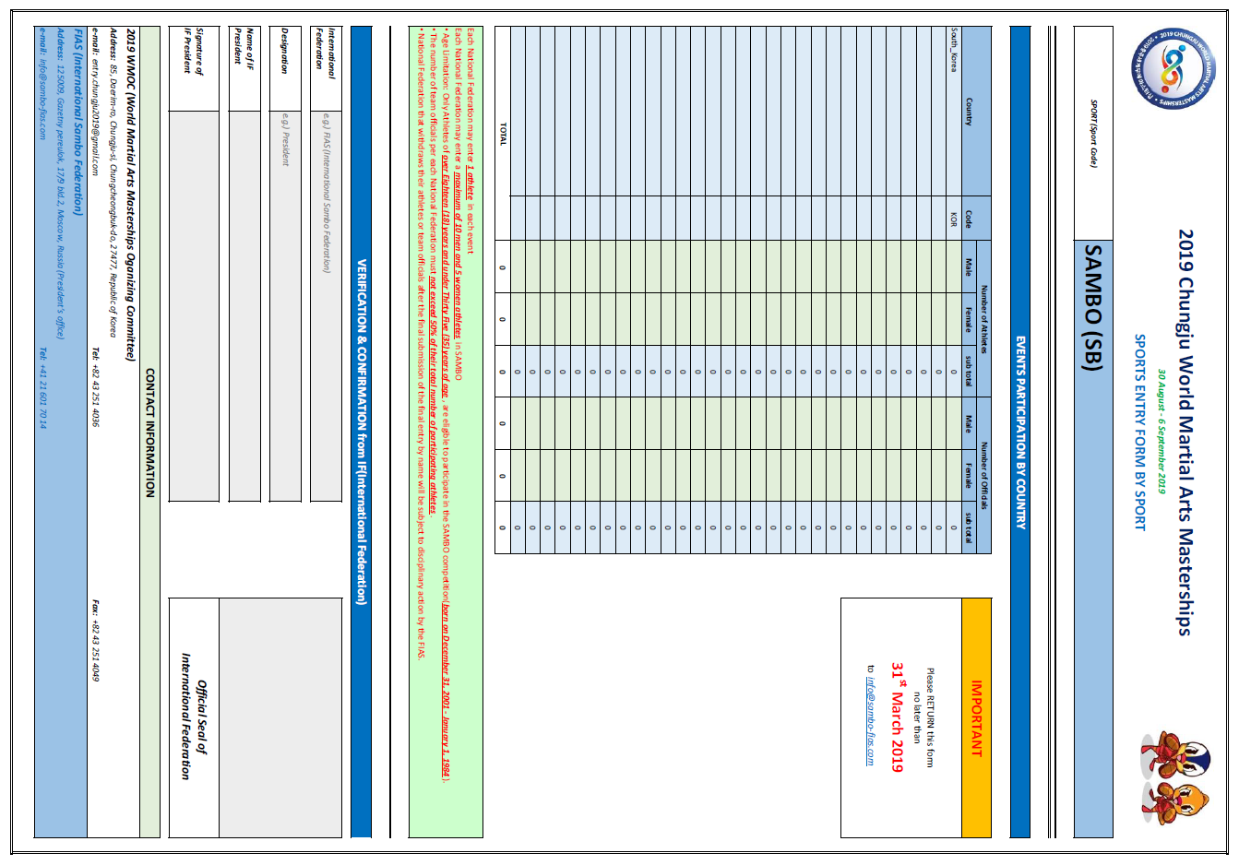

6.2. Entry Form by Number
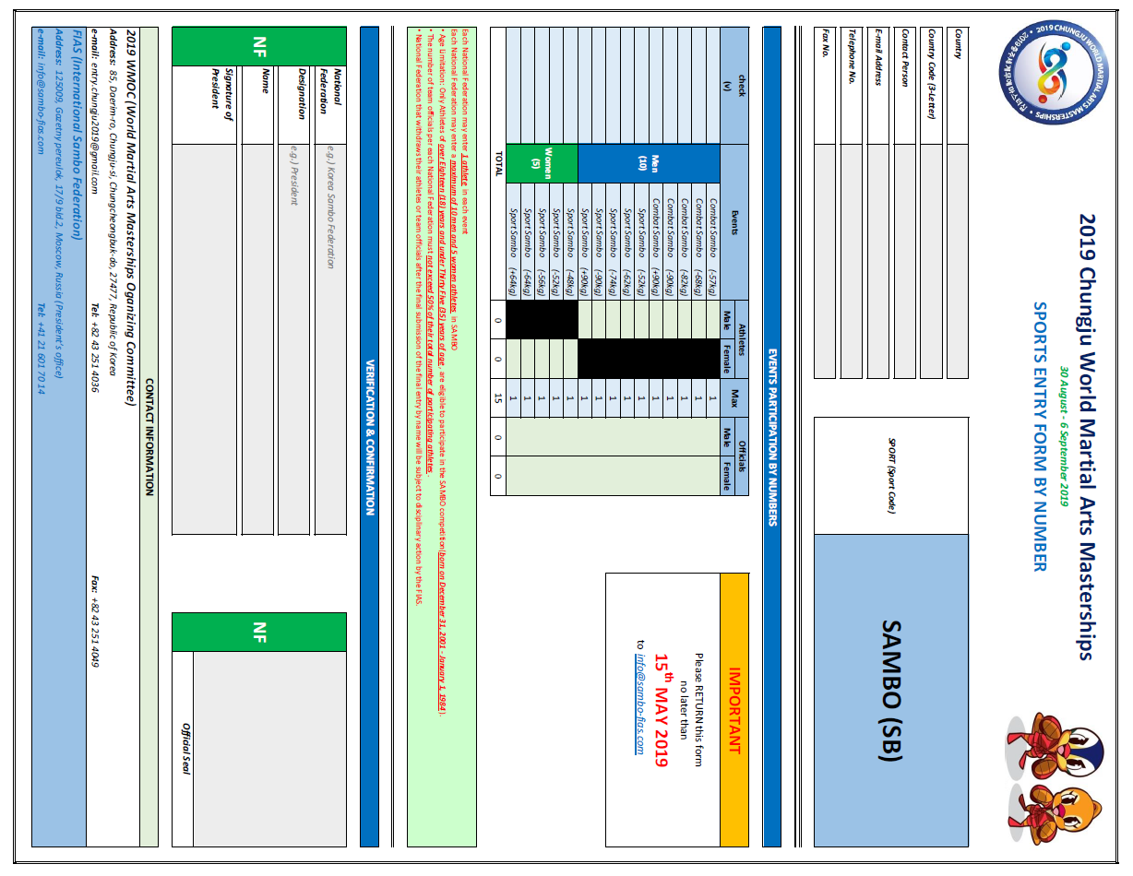

6.3. Entry Form by Name
