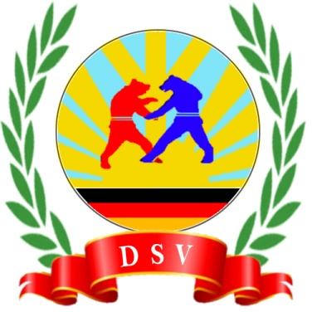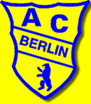

∗∗∗ SAMBO GERMANIADE 2014 ∗∗∗
International German Championship in Sport und Combat Sambo
REGISTRATION FORM
! Registration deadline: 15.10.2014 !
Country
City
Club
Contact person
Phone
E-Mail
For any questions
Mr. Andrej Bart
Tel: (0049) 162/ 901 85 25
E-Mail: samboka@gmx.de
S | Sport Sambo
C | Combat Sambo
V | Veteranen
Nr. | surname | first name | weight class | sex (m, f) | birth date | S | C | V
0 | Mustermann | Max | 99 kg | m | 07.11.2014 | x | x
1
2
3
4
5
6
7
8
9
10
11
12
13
14
15
16
17
18
19
20

